Implementation of DBMS Exercise Sheet 13 Kln., WS 2024 / 2025
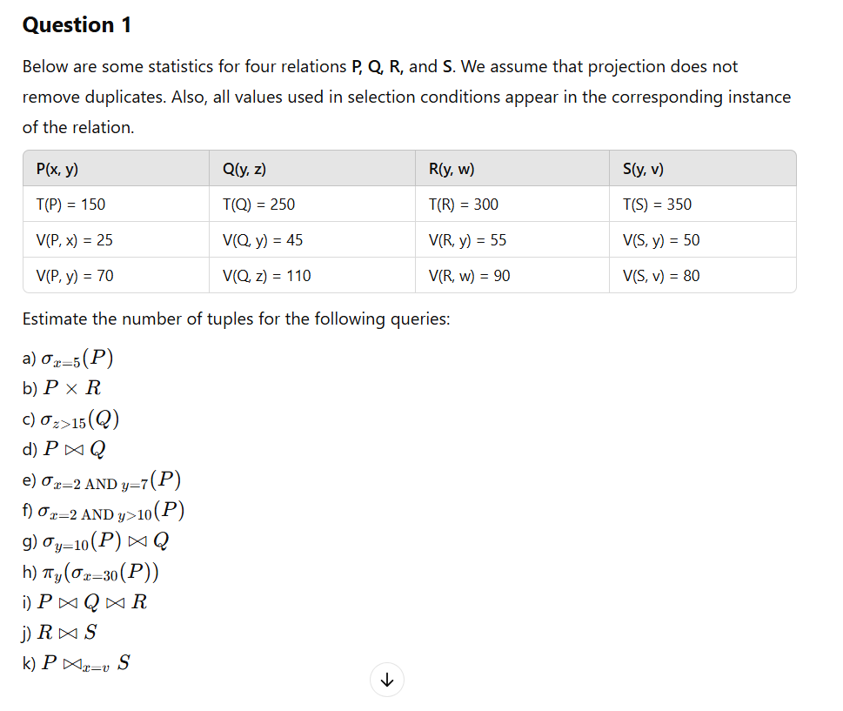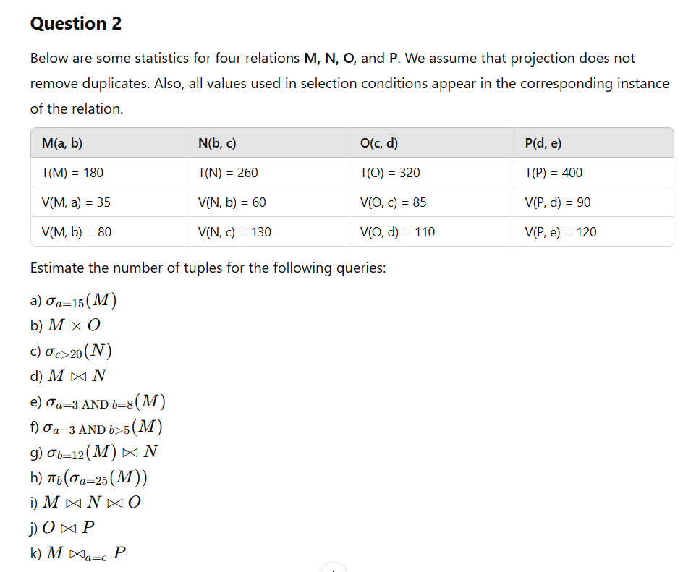

Question 1c:
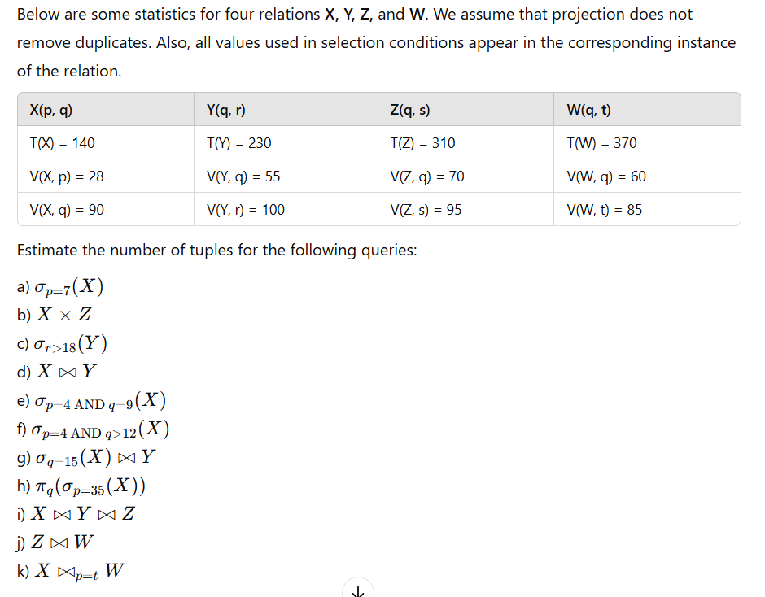
Question 2a:
A query optimizer is using statistical data for query estimation. Consider the following information about an attribute B of relation S. Attribute B is of type integer.
- There are 150 tuples with B values between 5 and 15. In this range, there are 6 unique B values.
- There are 250 tuples with B values between 16 and 25. In this range, there are 8 unique B values.
- There are 350 tuples with B values between 26 and 35. In this range, there are 9 unique B values.
- There are 450 tuples with B values between 36 and 50. In this range, there are 12 unique B values.
a) Consider the query σ_B=10(S). How many tuples are expected in the answer, assuming values are uniformly distributed over the possible V(S, B) values?
b) Consider the query σ_B=22(S). How many tuples are expected in the answer, assuming values are uniformly distributed over possible domain values?
c) Consider the query S ⨝ T, where S has attributes S(B, C, D) and T has attributes T(B, E, F). Assume that T has the same number of tuples as S, and that the B attribute in T has the same distribution as B in S. Assuming values are uniformly distributed over possible V(S, B) values, how many tuples are expected in the answer?

Question 2
A database system uses statistics to optimize query execution. The following details are known about an attribute C in relation T. Attribute C is of type integer.
- There are 200 tuples with C values between 10 and 20, where there are 5 unique C values.
- There are 300 tuples with C values between 21 and 30, where there are 7 unique C values.
- There are 400 tuples with C values between 31 and 40, where there are 9 unique C values.
- There are 500 tuples with C values between 41 and 50, where there are 10 unique C values.
a) Consider the query σ_C=12(T). How many tuples are expected in the answer, assuming values are uniformly distributed over the possible V(T, C) values?
b) Consider the query σ_C=35(T). How many tuples are expected in the answer, assuming values are uniformly distributed over the possible domain values?
c) Consider the query T ⨝ U, where T has attributes T(C, D, E) and U has attributes U(C, F, G). Assume that U has the same number of tuples as T, and that the C attribute in U has the same distribution as C in T. Assuming values are uniformly distributed over possible V(T, C) values, how many tuples are expected in the answer?

Question 3
A query optimizer analyzes statistical data for efficient query processing. Consider the following distribution of values for attribute D in relation U.
- There are 120 tuples with D values between 1 and 10, where there are 4 unique D values.
- There are 180 tuples with D values between 11 and 20, where there are 6 unique D values.
- There are 280 tuples with D values between 21 and 30, where there are 8 unique D values.
- There are 420 tuples with D values between 31 and 40, where there are 12 unique D values.
a) Consider the query σ_D=8(U). How many tuples are expected in the answer, assuming values are uniformly distributed over possible V(U, D) values?
b) Consider the query σ_D=19(U). How many tuples are expected in the answer, assuming values are uniformly distributed over possible domain values?
c) Consider the query U ⨝ V, where U has attributes U(D, E, F) and V has attributes V(D, G, H). Assume that V has the same number of tuples as U, and that the D attribute in V has the same distribution as D in U. Assuming values are uniformly distributed over possible V(U, D) values, how many tuples are expected in the answer?

📘 Teaching the Topics (Exercise Sheet 13)

🔹 1. Cardinality Estimation (Tuples Counts)
We are given statistics for relations:
- T(R): number of tuples in relation R.
- V(R, A): number of distinct values for attribute A in relation R.
👉 DBMS uses these statistics to estimate the size of query results.

🔹 2. Selection Estimation
- Equality:
∣σA=a(R)∣ = T(R)V(R,A)|
(Assumes uniform distribution).
- Inequality (>, <, ≥, ≤): often assume 1/3 or 1/2 of tuples qualify.

🔹 3. Cartesian Product
∣R×S∣=T(R)×T(S)
(no condition, just all pairs).

🔹 4. Join Estimation
For equi-join on attribute A:
∣R⋈S∣≈T(R)×T(S)max⁡(V(R,A),V(S,A))

If multiple attributes used, divide by product of max distinct counts for each.

🔹 5. Projection Estimation
- If duplicates not removed:
∣πA(R)∣=T(R)
- If duplicates removed:
∣πA(R)∣=V(R,A)

🔹 6. Combined Selections
For multiple conditions:
- AND: apply one after the other.
- OR: approximate with sum or inclusion-exclusion.

🔹 7. Histograms for Selections
- Example with ranges (A between 1–10, 11–20, etc.).
- Instead of global uniformity, we estimate within each bucket.
- This gives more precise cardinality estimation.

🔹 8. Join with Histogram Data
- Break down per bucket.
- Multiply tuples per value range for R and S, then divide by distinct values.
- Add up results across ranges.

✅ So the main skills practiced:
- Using formulas for selections, projections, joins.
- Handling compound conditions.
- Using histograms to improve estimates.

📝 New Practice Exercise Sheet (Similar Style)

Exercise Sheet – Query Size Estimation (Practice)

1. Given Relations:
We have the following relations with statistics:
- R(p, q) with T(R) = 120, V(R, p) = 30, V(R, q) = 40.
- S(q, r) with T(S) = 300, V(S, q) = 60, V(S, r) = 50.
- T(r, s) with T(T) = 500, V(T, r) = 100, V(T, s) = 80.
Tasks: Estimate the size of results:
a) σp=10(R)
b) R × S
c) R ⋈q S
d) σq>20(S)
e) σp=5 AND q=7(R)
f) σp=5 AND q>10(R)
g) πq(σp=10(R))
h) (R ⋈q S) ⋈r T

2. Histogram Estimation
Attribute A in relation U(A, B) has the following distribution:
- 100 tuples with A in [1, 10], 5 distinct A-values.
- 200 tuples with A in [11, 20], 4 distinct A-values.
- 300 tuples with A in [21, 30], 6 distinct A-values.
- 400 tuples with A in [31, 40], 8 distinct A-values.
Tasks:
a) Estimate |σA=8(U)|
b) Estimate |σA=15(U)|
c) Estimate |σA=28(U)|
d) If U ⋈A V, where V has the same distribution as U and T(V)=1000, estimate |U ⋈ V|.

Perfect — since you’re preparing at Master’s level (Computer Science), let’s step up the difficulty. Instead of just direct cardinality formulas, we’ll design exam-style problems that test deeper understanding:
- Multi-join query estimation
- Histograms with skewed distributions
- Index-based cost models
- Algebraic rewriting for optimization
- Edge cases like correlations & independence assumptions

🎓 Advanced Exam Questions – Query Processing & Estimation

Q1. Multi-Join Cardinality with Compound Conditions
Relations:
- R(a, b), T(R) = 1000, V(R, a) = 100, V(R, b) = 200
- S(b, c), T(S) = 2000, V(S, b) = 250, V(S, c) = 400
- T(c, d), T(T) = 3000, V(T, c) = 500, V(T, d) = 600
Task:
Estimate the result size of the query:
πa,d(σa<50∧c>200(R⋈S⋈T))π_{a,d}(σ_{a<50 ∧ c>200}(R ⋈ S ⋈ T))
Show each step: selections, join orders, and final projection.

Q2. Histogram-Aware Estimation with Skew
Relation U(A, B) has the following histogram for A:
- [1–10]: 500 tuples, 5 distinct A-values
- [11–20]: 200 tuples, 10 distinct A-values
- [21–30]: 300 tuples, 3 distinct A-values
Tasks:
a) Estimate |σA=7(U)| under the histogram.
b) Suppose query is σA>15(U). Estimate result size.
c) If V(A) values are heavily skewed (value 7 appears in 400 of the 500 tuples in [1–10]), what happens to (a)?

Q3. Index Cost Estimation
Relation R(a, b) with T(R)=100,000, B(R)=2000 disk blocks.
- Attribute a has V(R, a) = 1000.
- Attribute b has V(R, b) = 100,000.
- There is a clustered B+Tree index on a, and a non-clustered B+Tree index on b.
Tasks:
a) Estimate the I/O cost of query σa=100(R).
b) Estimate the I/O cost of query σb=50(R).
c) Explain why clustered vs. non-clustered index matters here.

Q4. Query Rewriting & Optimization
Given the query:
SELECT R.a, T.d
FROM R, S, T
WHERE R.b = S.b AND S.c = T.c
AND R.a < 50 AND T.d > 100;
Tasks:
a) Write the initial relational algebra expression.
b) Apply algebraic rules to push down σ and π.
c) Suggest the best join order based on the given stats:
- T(R)=5000, V(R,b)=200
- T(S)=20000, V(S,b)=400, V(S,c)=300
- T(T)=15000, V(T,c)=500

Q5. Correlated Attribute Estimation
Relation V(x, y), T(V)=10,000.
- V(x)=100 distinct values, V(y)=100 distinct values.
- But x and y are fully correlated (each x maps to exactly one y).
Tasks:
a) Estimate |σx=y(V)| under independence assumption.
b) Compute the true size given correlation.
c) Discuss why independence assumption can fail in query optimizers.

Q6. Advanced Join Estimation (Two-Attribute Join)
Relations:
- W(a, b), T(W)=2000, V(W, a)=100, V(W, b)=50
- Z(b, a), T(Z)=3000, V(Z, b)=50, V(Z, a)=100
Task:
Estimate |W ⋈(W.a=Z.a ∧ W.b=Z.b) Z|.
Compare the result with:
- Join on only a.
- Join on only b.

✅ What These Questions Test
- Q1: Multi-join pipelines, order matters.
- Q2: Histograms & skew vs. uniform assumptions.
- Q3: Cost model & index types.
- Q4: Algebraic rewriting + join ordering.
- Q5: Correlations & optimizer pitfalls.
- Q6: Multi-attribute join cardinality.

